**Ville Hokkinen 2631901 Weekly diary Digital Fabrication**

Week 1

Kick of and brainstorming. We come up with home automation window blinds opener. Some buzzing on how to implement it and finish the introductory report. The initial drafts I made with paint by drawing block. It came out great.

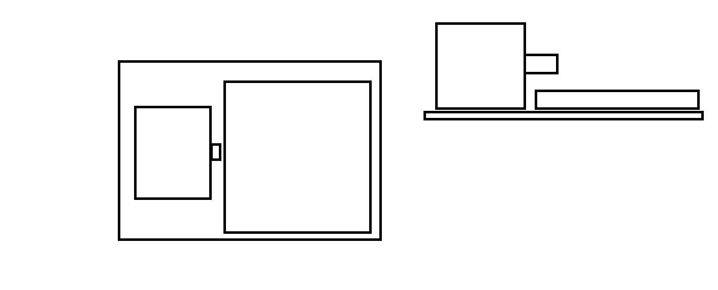

Week 2

Nothing, focusing on work.

Week 3

Start 3D modeling the different pieces and create a primary assembly in inventor. It turns out having multiply pieces fit together is hell. Every time a slight adjustment was made it broke the whole thing.

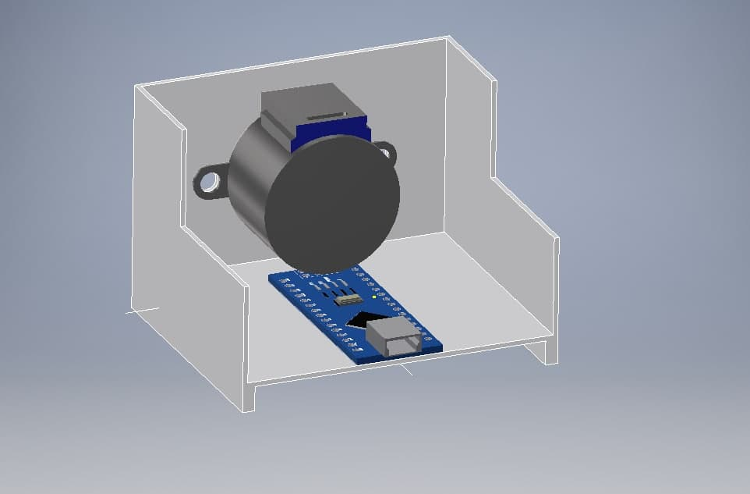

Week 4

3D model different components included in the project and implement them in assembly. Learned how to fit the pieces together. The same thing continued with the pieces not working, but the deeper understanding of constraints in the assembly helped me with sustainable development

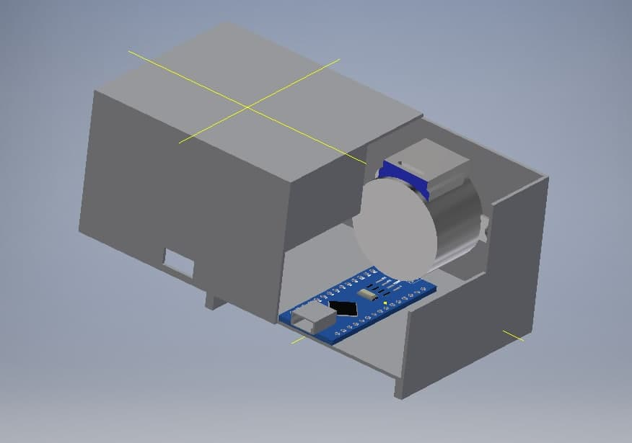

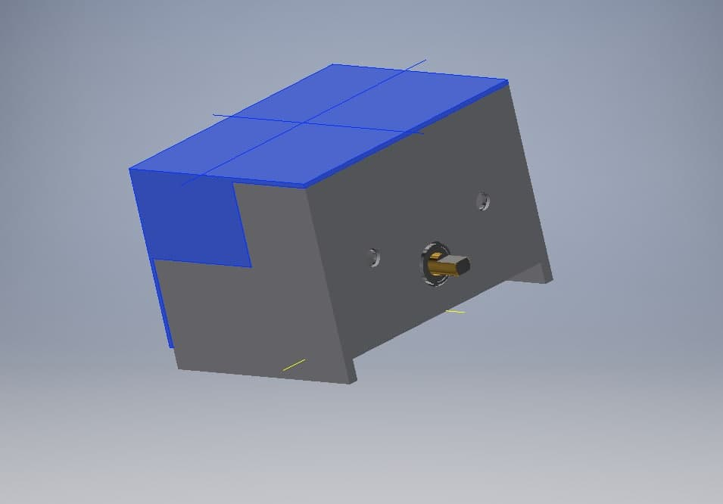

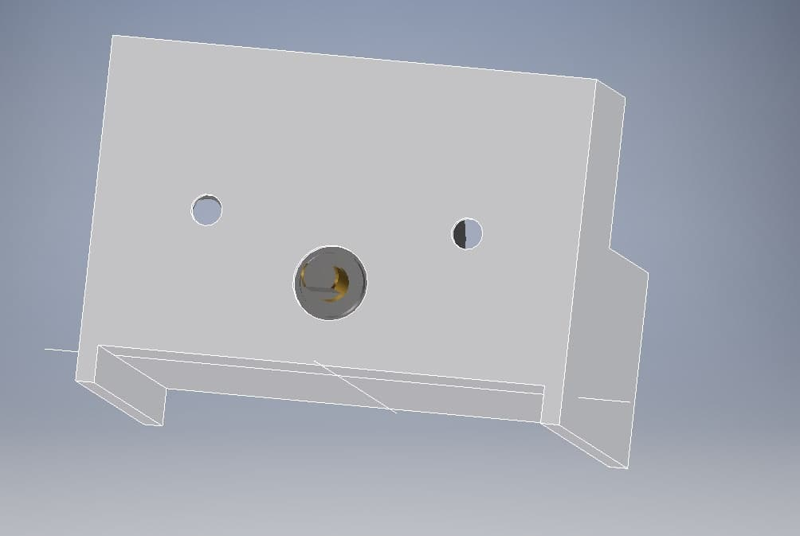

Week 5

Help in creating the code to run the motor. Finally found a stepper motor in tinkercad and managed to get it to work.

Week 6

Create the summary report with the team, one final look over the assembly. Its beautiful.